Scan options (if using a film)

- Scan with high quality printer
- Add the WB films to a blank A4 sheet and put them in the scanning area of the printer
- Check if the following options are selected:
- Document File Type: TIFF; Click File options and select LZW as compression type
- Resolution: 300dpi
- Colour: Black/Gray (Don’t choose Black only)

Analysis options
- Open ImageJ
- With the rectangle option, draw a rectangle on the first lane (this is the area that will be selected for all the lanes and should be able to fit any other band of the gel)

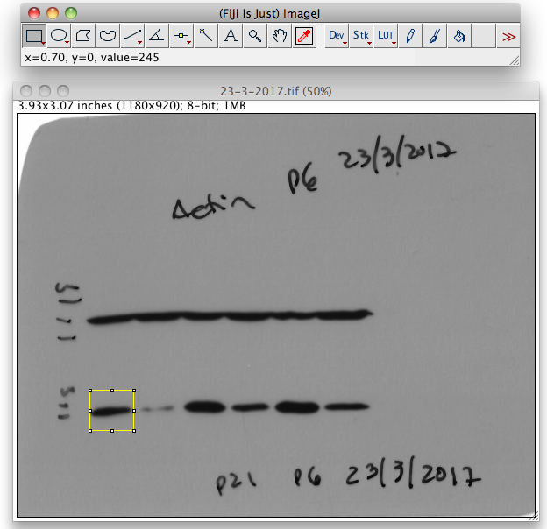

- Click cmd+1 (or Ctrl+1 on a PC) to define the first area
- Move the rectangle to the next lane and click cmd+2 (or Ctrl+2 on a PC)
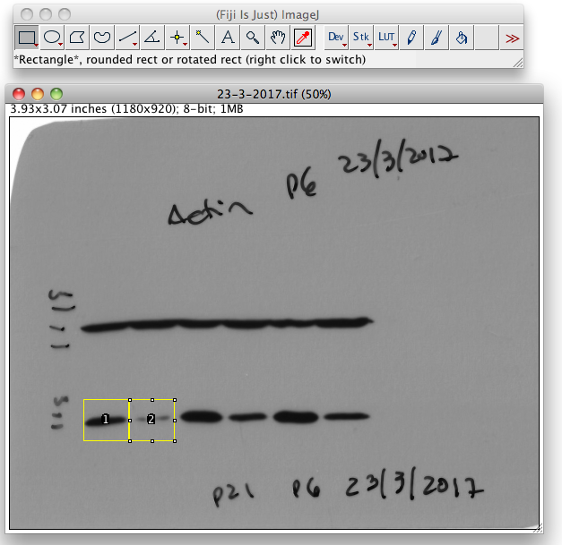
- Repeat 4. For all the lanes
- When all the lanes are selected click cmd+3 (or Ctrl+3 on a PC) and the histograms window will appear

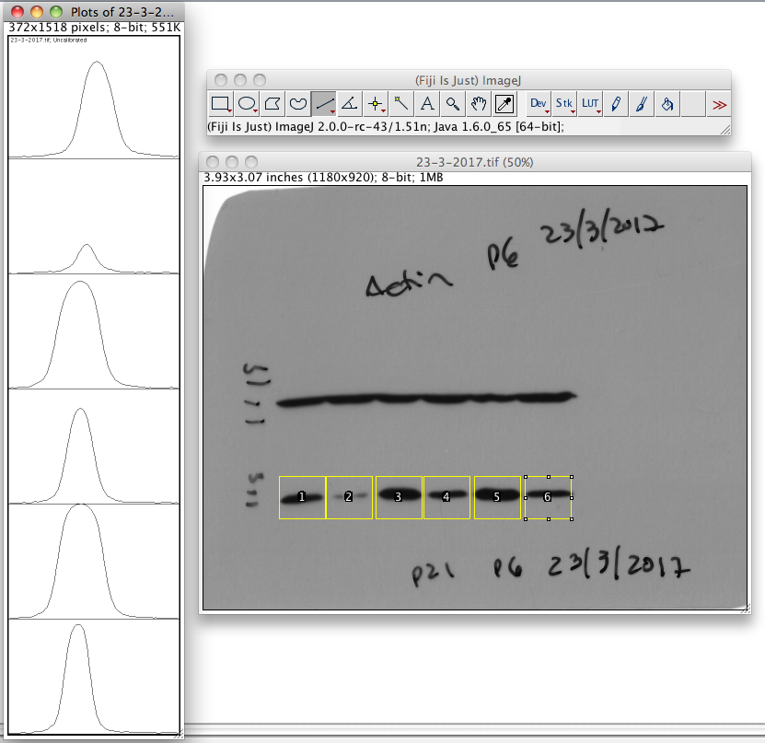
- Use the line option to draw a line eliminating the background for each single lane (the background should be similar for all the lanes of the same film)
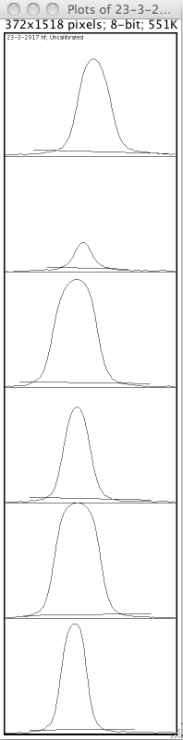
- Use the Magic Wand option to quantify the area of each band (the measurements window will appear) by clicking inside each peak of the histogram
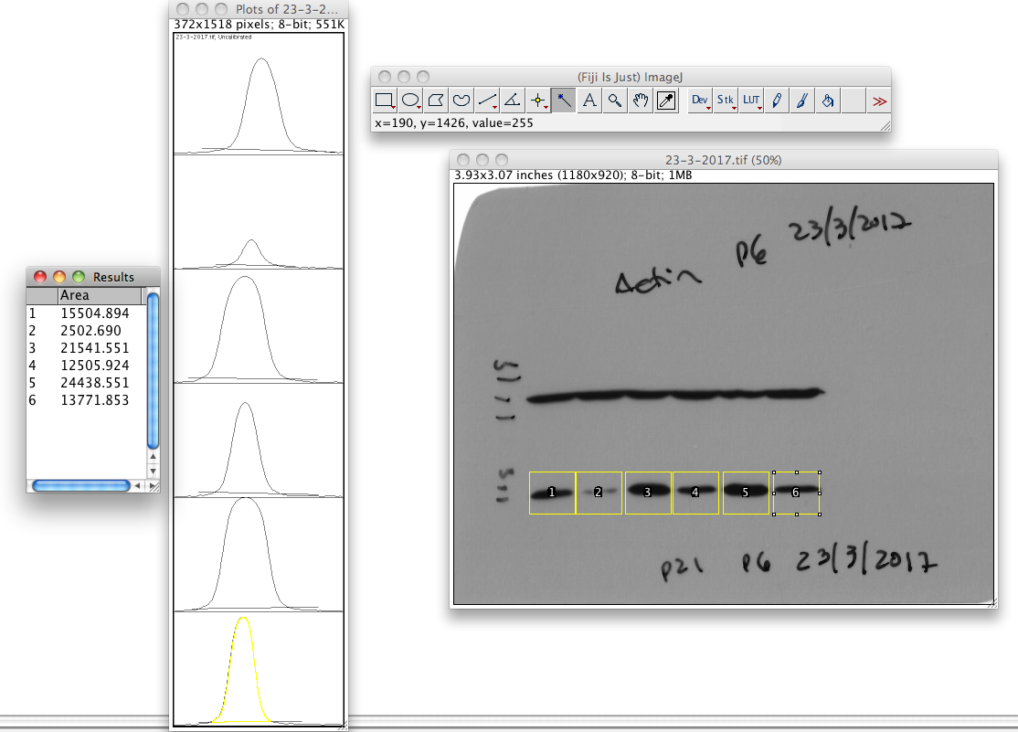

- Select all the data on the measurements window and copy it to excel
- Each gel should be normalized to a loading control so that for the sample 1 should be calculated the area of gene X divided by the area of the loading control. For example the area for the FtH Ab divided by the area for actin.

